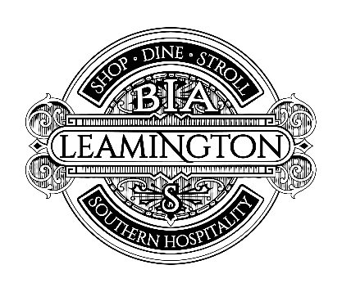
LEAMINGTON BIA Board Meeting AGENDA

Thursday, August 16, 2018 8:30am-10am
Leamington Arts Centre 72 Talbot St W, Leamington

- CALL TO ORDER

- ADDITIONS OR AMENDMENTS TO THE AGENDA (2 mins)

- REVIEW & APPROVAL OF PREVIOUS MEETING MINUTES (2 mins)

- TREASURER’S REPORT (2 mins)

- REPORT FROM COUNCIL REPRESENTATION (5 mins)

- REPORT FROM LEAMINGTON CHAMBER (5 mins)

- UPTOWN SIDEWALK SALE RECAP (5 mins)

- COUNCIL MEETING AGENDA (20 mins)

- ART IN THE PARKETTE EVENT (20 mins)

- SECURITY CAMERA GRANT APPLICATION SUBMISSIONS (10 mins)

- UPLIFT GRANT SUBMISSIONS (10 mins)

- BIA MEMBERSHIP REQUESTS/COMMENTS/CONCERNS

- NEW BUSINESS

- ADJOURNMENT

*Next Board Meeting Date September 20, 2018

