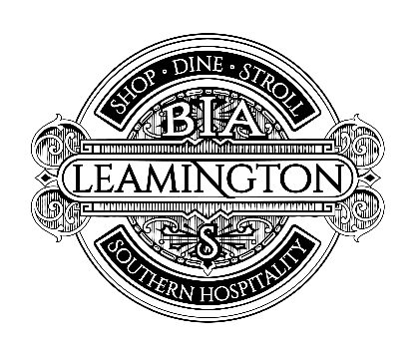
LEAMINGTON BIA Board Meeting AGENDA

Thursday, September 20, 2018 8:30am-10am
Gabriele BrandSource, Talbot St W, Leamington

- CALL TO ORDER

- ADDITIONS OR AMENDMENTS TO THE AGENDA (2 mins)

- REVIEW & APPROVAL OF PREVIOUS MEETING MINUTES (2 mins)

- DELEGATION REQUESTS
  - D. Friesen (5 mins)
  - B. Scott (5 mins)
  - K. Sousa (5 mins)

- TREASURER’S REPORT (2 mins)

- REPORT FROM COUNCIL REPRESENTATION (5 mins)

- REPORT FROM LEAMINGTON CHAMBER (5 mins)

- ART IN THE PARKETTE EVENT (10 mins)

- SECURITY CAMERA GRANT APPLICATION SUBMISSIONS (10 mins)

- UPLIFT GRANT SUBMISSIONS (10 mins)

- DIGITAL MAINSTREET (5 mins)

- HALLOWEEN CRAWL (5 mins)

- BIA BUCKS (5 mins)

- CHRISTMAS OPEN HOUSE (5 mins)

- CHRISTMAS POTS (5 mins)

- TASTE LEAMINGTON (5 mins)

- BIA MEMBERSHIP REQUESTS/COMMENTS/CONCERNS

- NEW BUSINESS

- ADJOURNMENT

*Next Board Meeting Date October 18, 2018

